**Bug Report**

**Description :**

**Firefox :Client side throws error while backend created the user successfully.**

**Steps to reproduce :**

1. **Visit heal.com/patient**
2. **Submit the form with valid data and zipcode**
3. **Click submit**
4. **Observe the client side error “something went wrong”-see screen shot1**
5. **Click Submit (again)**

**Actual Result:**

**Username already exists, please see screenshot2**

**Expected Result:  
Since user was successfully created, user should no longer be on register screen.**

**Notes:**

**Need to look at server logs to see if backend gave the 200 ok status which front-end didn’t interpret or why did backend give a error code while user was successfully created on backend.**

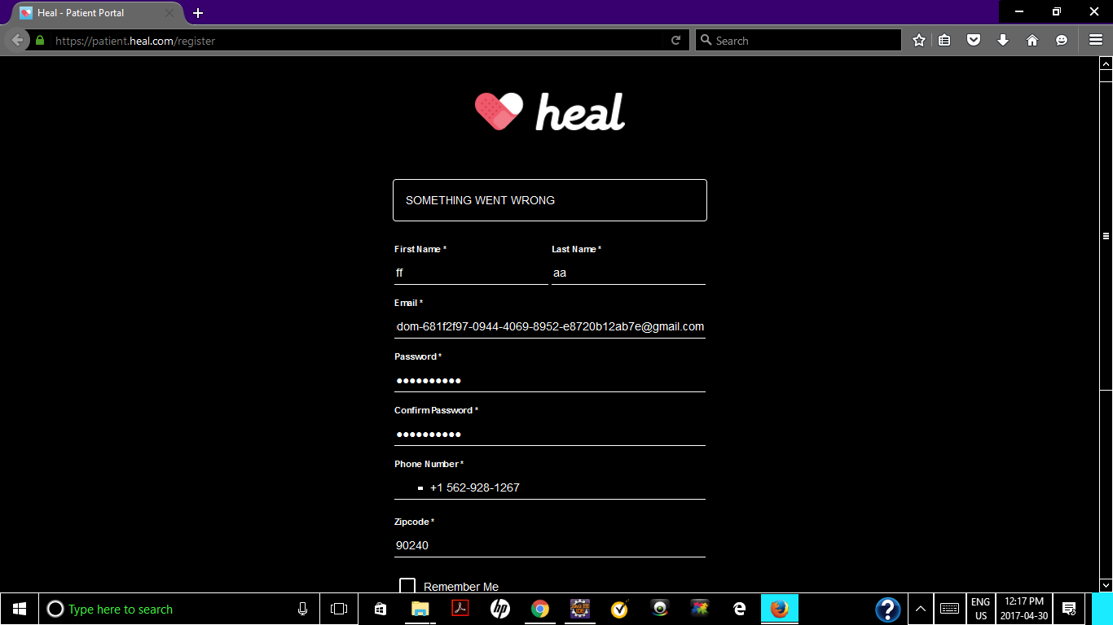

**2) Site looks different in Firefox Browser**

**Please see screenshot.**

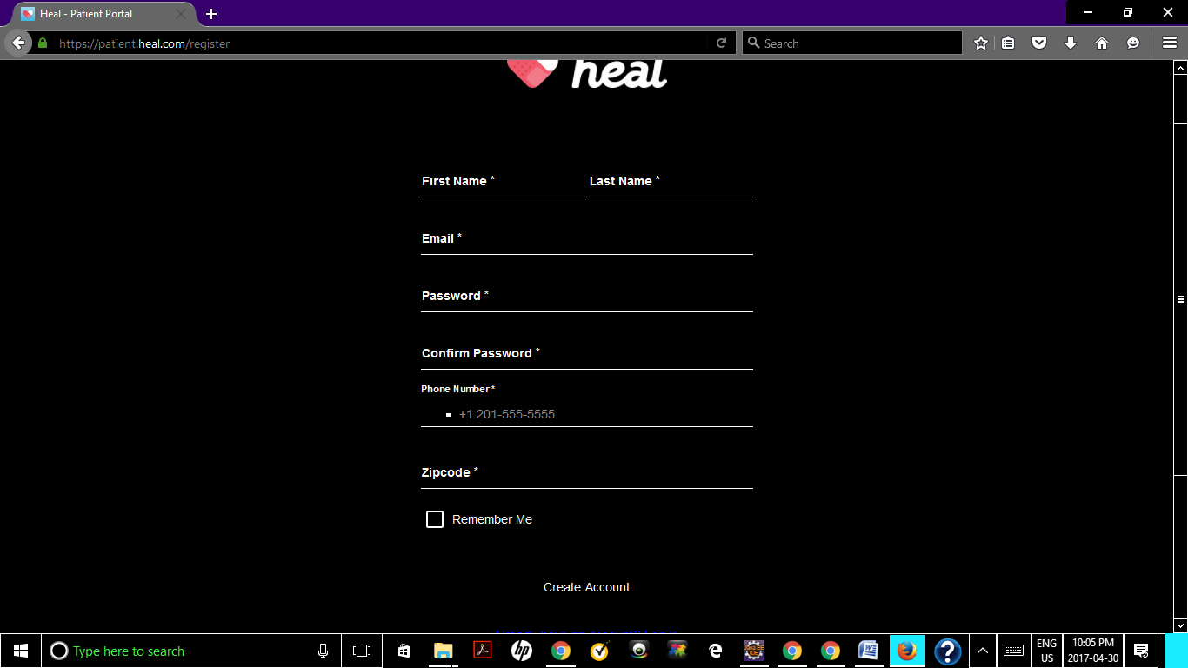

**Enhancement**

**Description :**

**Notify me not working**

**Steps to reproduce :**

**1)visit heal.com/patient**

**2)submit the form with valid data and zipcode 90240**

**3)click submit**

**4)Successfull submission with says“Heal not in your area”**

**5)click Notify me**

**Actual Result:**

**Bring back to Registration page**

**Expected Result**

**Some Kind of intuitivePage which shows email is noted and will be informed once available**

